**DATA ANALYTICS WITH TABLEAU**

**ASSIGNMENT-4**

TASK 1- CREATE ONE FIXED LOD AND ONE EXCLUDE LOD EXPRESSION.

🡪FIXED LOD

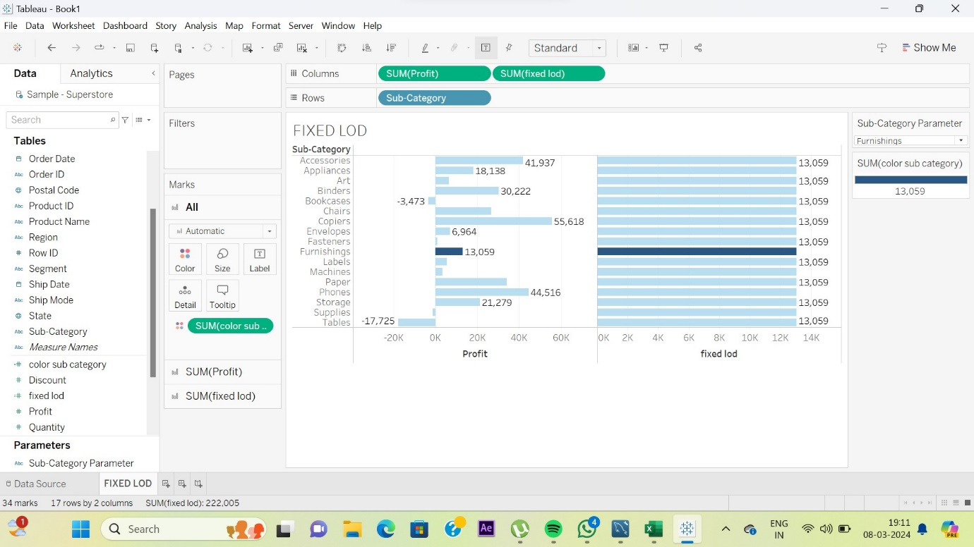

* The above visualization is Horizontal bars visualization.
* In this visualization FIXED LOD is used.
* Formula used in this LOD is :

{FIXED[Category]:SUM([Profit])}

* In the above visualization “Furnishings” is the sub category which is highlighted with the total SUM as 13,059.
* If we want to display the total of any other sub category we can change the sub category in the right hand side ‘sub category parameter’ bar.

🡪EXCLUDE LOD

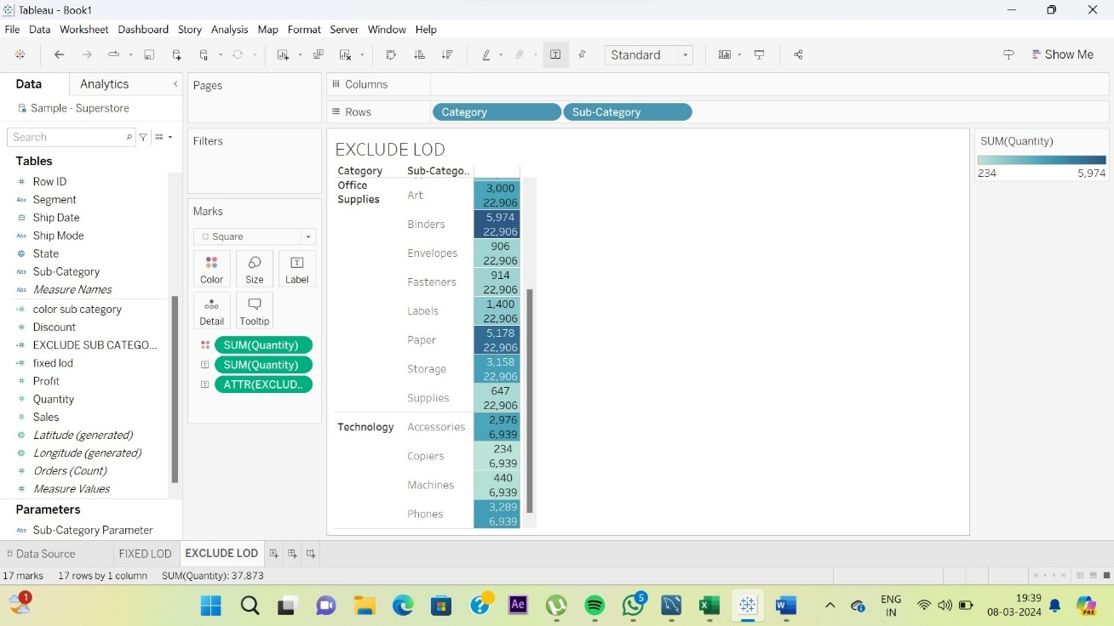

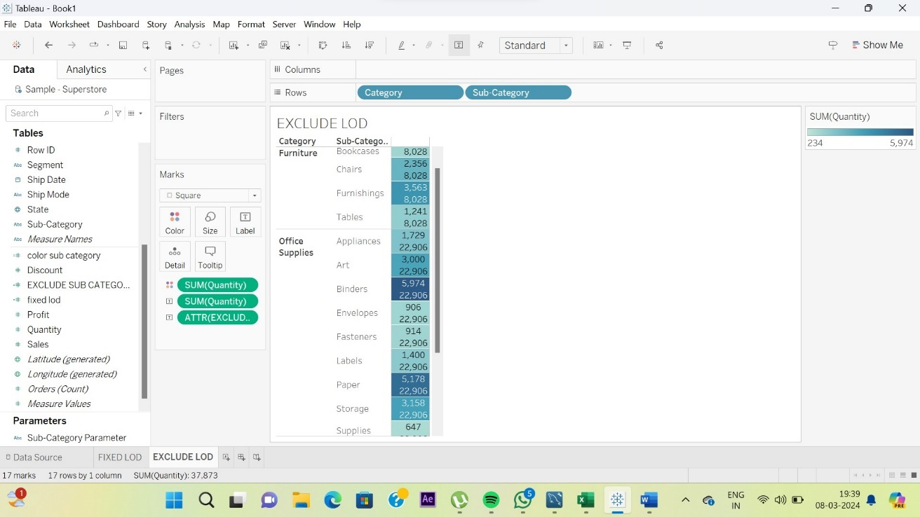

* The above visualization is Highlight tables visualization.
* In this visualization EXCLUDE LOD is used.
* Formula used in this LOD is :

{EXCLUDE [Sub-Category]:SUM([Quantity])}

* The above visualization defines the total quantity and the quantity is excluded for sub category as we used EXCLUDE LOD.

TASK 2-CREATE 2 MAP VISUALIZATIONS USING GEOGRAPHICAL DATA.

SYMBOL MAPS

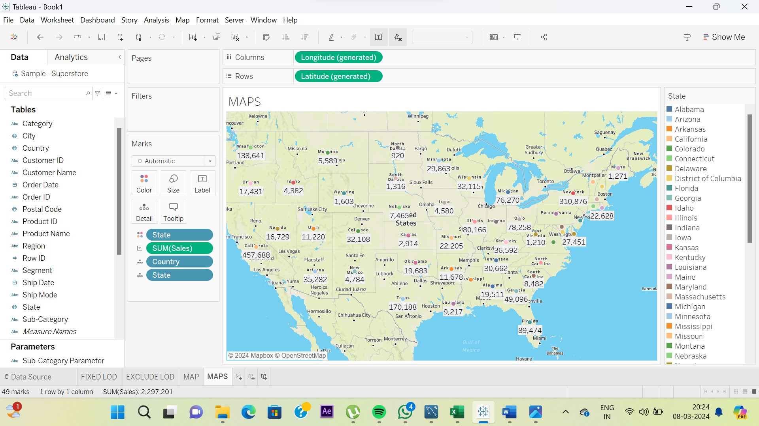

* The above visualization is Symbol Map visualization.
* The visualization represents the sales in different states of United States.
* The different colour dots represent different states with the total sales displayed below the state names.
* (We can also change the shapes of the markings using shape options.)

MAPS

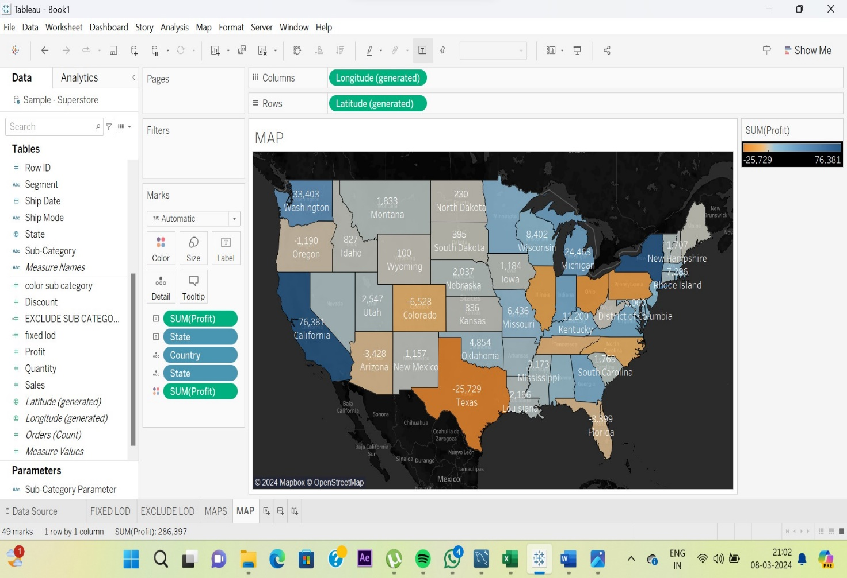

* The above visualization is called Map visualization.
* The visualization represents the Profit in different states of United States.
* The different coloured shapes represent different states of the United States with the profit for each state displayed below the state name.

TASK 3- CREATE TOP N AND/OR DYNAMIC PARAMETERS AND UTILIZE THOSE IN YOUR WORKBOOK.

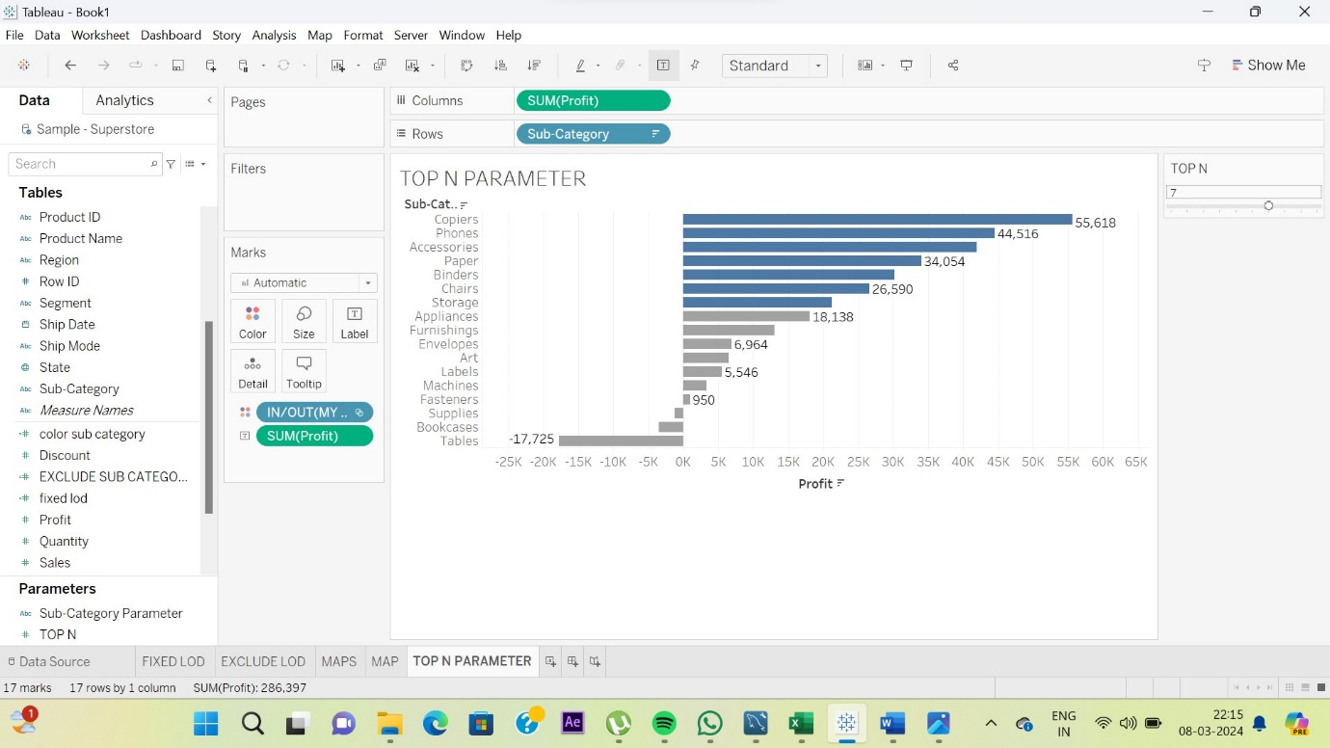

* This visualization is horizontal bars visualization.
* In this visualization we have represented the profits of different sub categories.
* We have used a parameter in this visualization known as TOP N parameter which is created by the user. This parameter also gives us the access to change the display bar of the number of sub categories to be displayed.
* We have created a set named MY SET to display the total sub categories .
* By using this set we can select the sub categories which are to be displayed by highlighting only them.
* In the above visualization we have selected no. 7 in the slide bar so only the top 7 sub categories have been marked or highlighted in different colour and the other sub categories have been marked in different colour.
* We can change the number in the slide bar according to the visualization.